# Assignment -2

Data Visualization and Preprocessing

|  |  |
| --- | --- |
| Assignment Date | 19 November 2022 |
| Student Name | C.Rosy |
| Student Roll Number | 820519106029 |
| Maximum Marks | 2 Marks |

# Question-1:

Download the dataset:

# Question-2:

Load the dataset.

# Solution:



import pandas as pd

import matplotlib.pyplot as plt

%matplotlib inline import seaborn as sns import numpy as np



df = pd.read_csv('/content/drive/MyDrive/eec/Churn_Modelling.csv')

df.head()

**Question-3:**

Perform Below Visualizations. 1)Univariate Analysis

# Solution:



plt.hist(df['NumOfProducts'])

2)Bi - Variate Analysis

# Solution:



sns.barplot(x=df.NumOfProducts,y=df.Tenure)

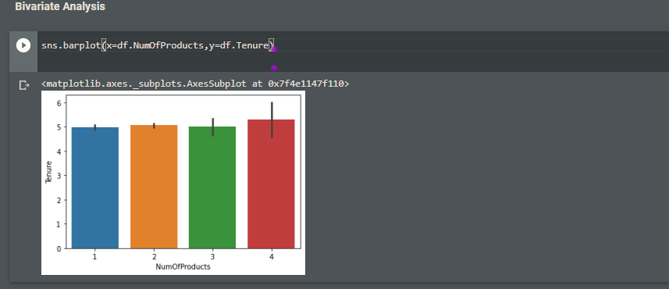

1)Multivariate Analysis

# Solution:

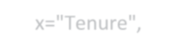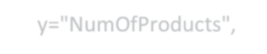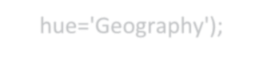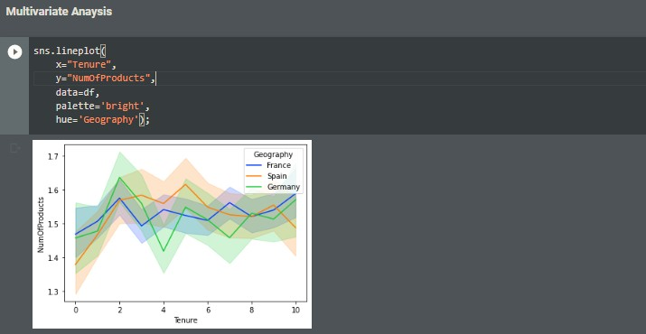

sns.lineplot(

x="Tenure", y="NumOfProducts", data=df, palette='bright', hue='Geography');

**Question-4:**

Perform descriptive statistics on the dataset.

# Solution:

df**.**describe()

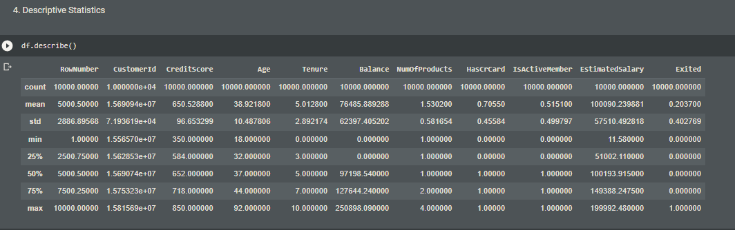

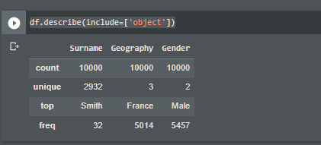

df.describe(include=['object'])

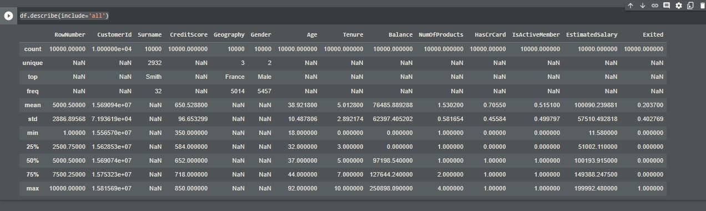



df.describe(include='all')

# Question-5:

Handle the Missing values.

# Solution:

df**.**fillna(0)

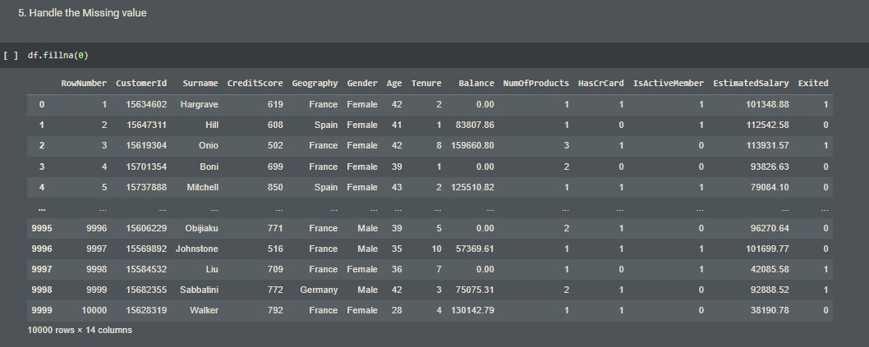



d.isnull(df["HasCrCard"])

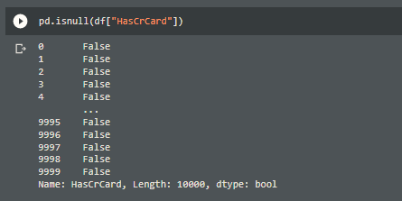

# Question-6:

Find the outliers and replace the outliers

# Solution:

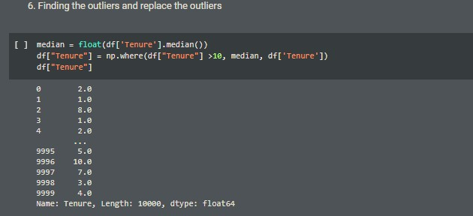

median = float(df['Tenure'].median())

df["Tenure"] = np.where(df["Tenure"] >10, median, df['Tenure']) df["Tenure"]

**Question-7:**

Check for Categorical columns and perform encoding.



**Solution:**

pd.get_dummies(df, columns=["Tenure","CreditScore"], prefix=["CreditScore","Tenure"]).head()

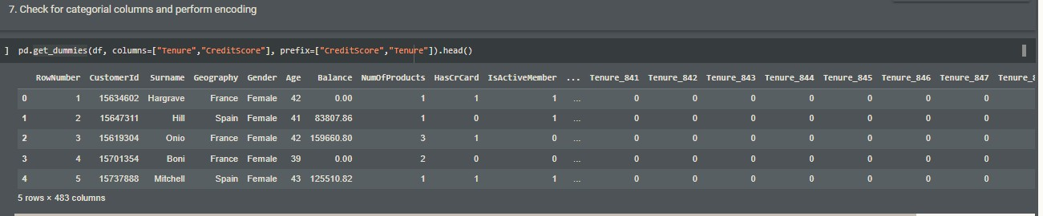

# Question-8:

Split the data into dependent and independent variables.

# Solution:

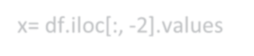

Dependent Variable

x= df.iloc[:, -2].values

print(x)

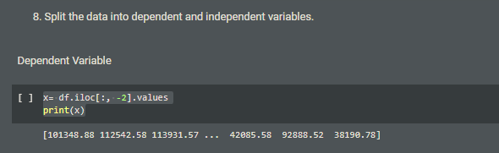

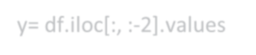

Independent Variable

y= df.iloc[:, :-2].values print(y)

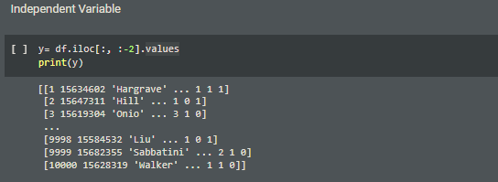

**Question-9:**

Scale the independent variables

# Solution:

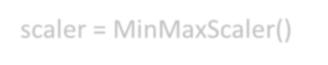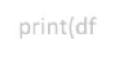

from sklearn.preprocessing import MinMaxScaler

scaler = MinMaxScaler()

df[["Tenure"]] = scaler.fit_transform(df[["Tenure"]]) print(df)

**Question-10:**

Testing and training data

# Solution:

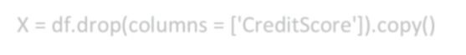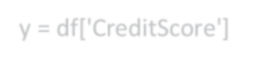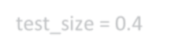

from sklearn.model_selection import train_test_split

train_size=0.7

X = df.drop(columns = ['CreditScore']).copy() y = df['CreditScore']

X_train, X_rem, y_train, y_rem = train_test_split(X,y, train_size=0.7)

test_size = 0.4

X_valid, X_test, y_valid, y_test = train_test_split(X_rem,y_rem, test_size=0.4) print(X_train.shape), print(y_train.shape)

print(X_valid.shape), print(y_valid.shape) print(X_test.shape), print(y_test.shape)